**Assignment 13: Iterator Design Pattern**

**What is Iterator Design Pattern?**

The **Iterator** design pattern allows us to **traverse** a collection of objects **without exposing** the underlying **implementation** of the collection.

**Structure (Class Diagram)**

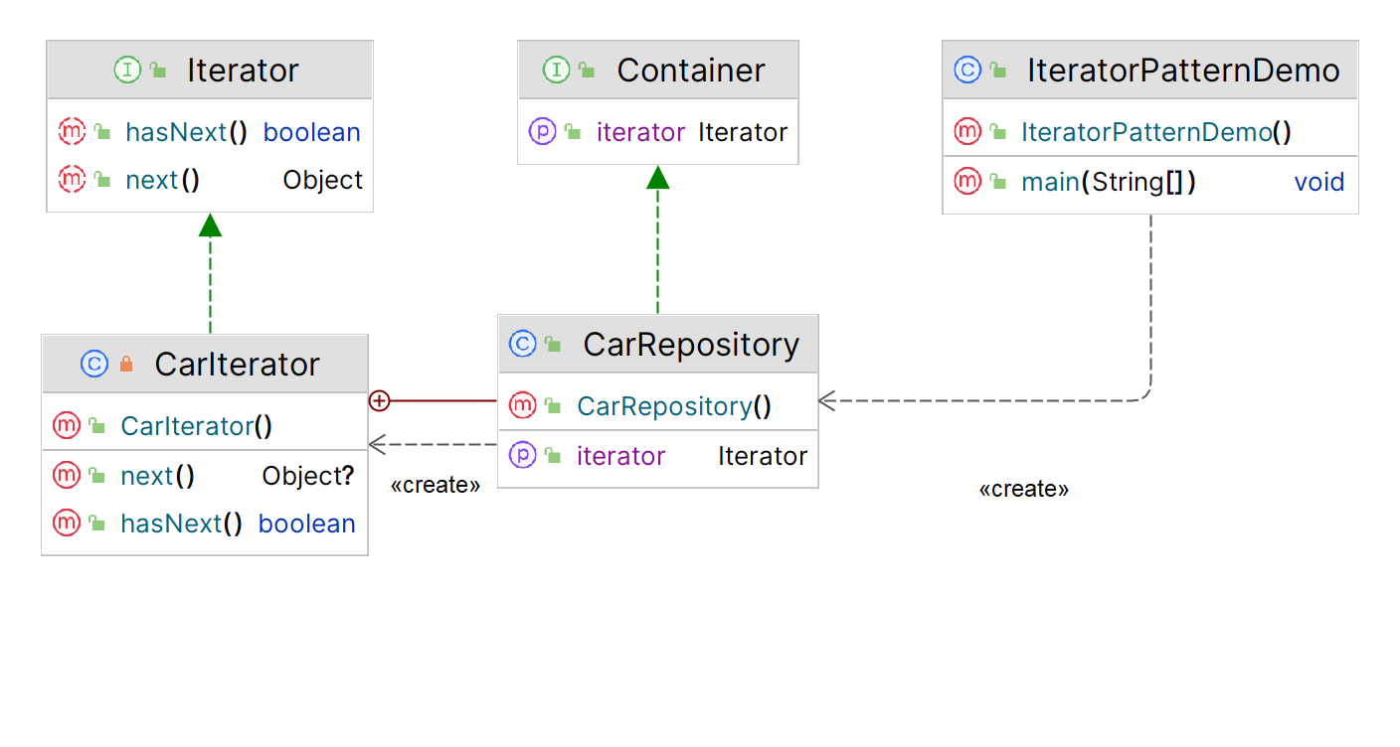

**Implementation (Code)**

|  |
| --- |
| ***// Interface for Iterator***public interface Iterator {  public boolean hasNext();  public Object next(); }  ***// Returns new instances of Iterator***public interface Container {  public Iterator getIterator(); }  ***// Concrete Iterator to implement traversal of repository*** public class CarRepository implements Container {  public String cars[] = {"Mercedes", "BMW", "Audi", "Ferrari", "Jaguar"};   public Iterator getIterator() {  return new CarIterator();  }   private class CarIterator implements Iterator {  int index;  public boolean hasNext() {  if (index < cars.length) {  return true;  }  return false;  }   public Object next() {  if (this.hasNext()) {  return cars[index++];  }  return null;  }  } }  ***// Demo - Main***public class IteratorPatternDemo {  public static void main(String[] args) {  CarRepository carRepo = new CarRepository();   for (Iterator iter = carRepo.getIterator(); iter.hasNext();) {  String name = (String)iter.next();  System.*out*.println("Car : " + name);  }  } }  **Output** |

**Applicability**

1. Use the **Iterator** pattern when your collection has a **complex data structure** under the hood, but you want to **hide its complexity from clients** (either for convenience or security reasons).
2. Use the pattern to **reduce duplication** of the traversal code across your app.
3. Use the Iterator when you want your code to be able to traverse different data structures or **when types of these structures are unknown** beforehand.